# Task 7.1 Preparation

## 1.1: What are the minimum requirements to install Ubuntu 14 on a desktop

### Ubuntu 14 (32-bit)

• 700 MHz processor (about Intel Celeron or better)

• 512 MiB RAM (system memory)

• 5 GB of hard-drive space (or USB stick, memory card or external drive but see LiveCD for an alternative approach)

• VGA capable of 1024x768 screen resolution

### Ubuntu 14 (64-bit)

• 700 MHz processor (about Intel Celeron or better)

• 512 MiB RAM (system memory)

• 5 GB of hard-drive space (or USB stick, memory card or external drive but see LiveCD for an alternative approach)

• VGA capable of 1024x768 screen resolution

## 1.2: Ubuntu is one of Linux distributions. What is the meaning of a Linux distribution?

## 1.3: List 5 popular Linux distributions.

1. Ubuntu
2. Linux Mint
3. Debian
4. Fedora
5. CentOS / Read Hat Enterprise Linux
6. Arch Linux
7. Slackware Linux
8. Puppy Linux

# Task 7.2: Download Ubuntu 14 Installation File

<http://releases.ubuntu.com/14.04/>

# Task 7.3: Installation

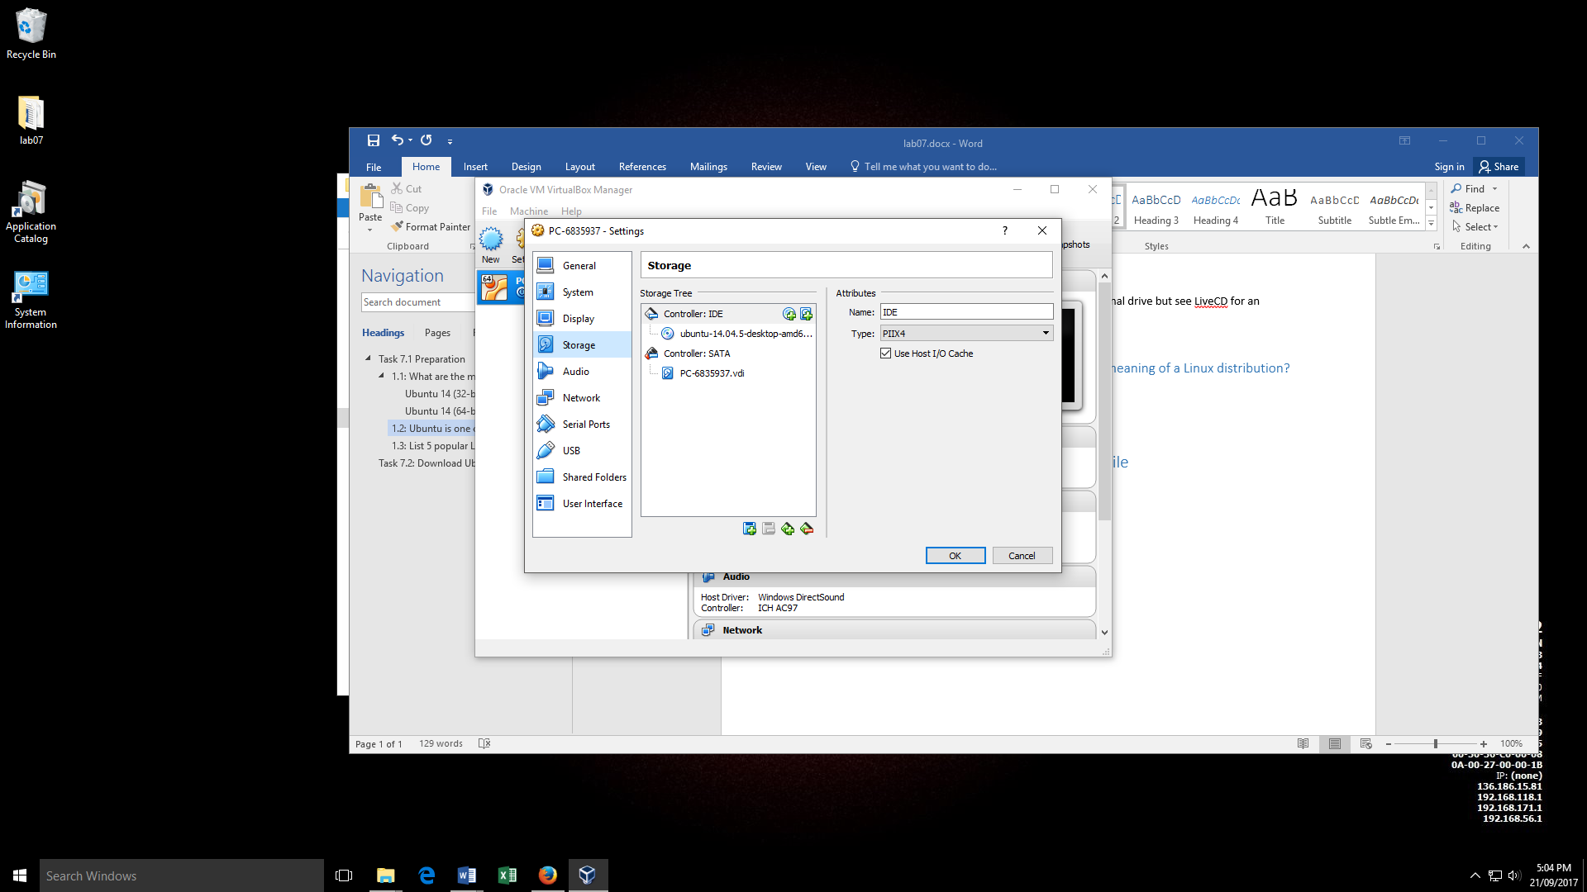

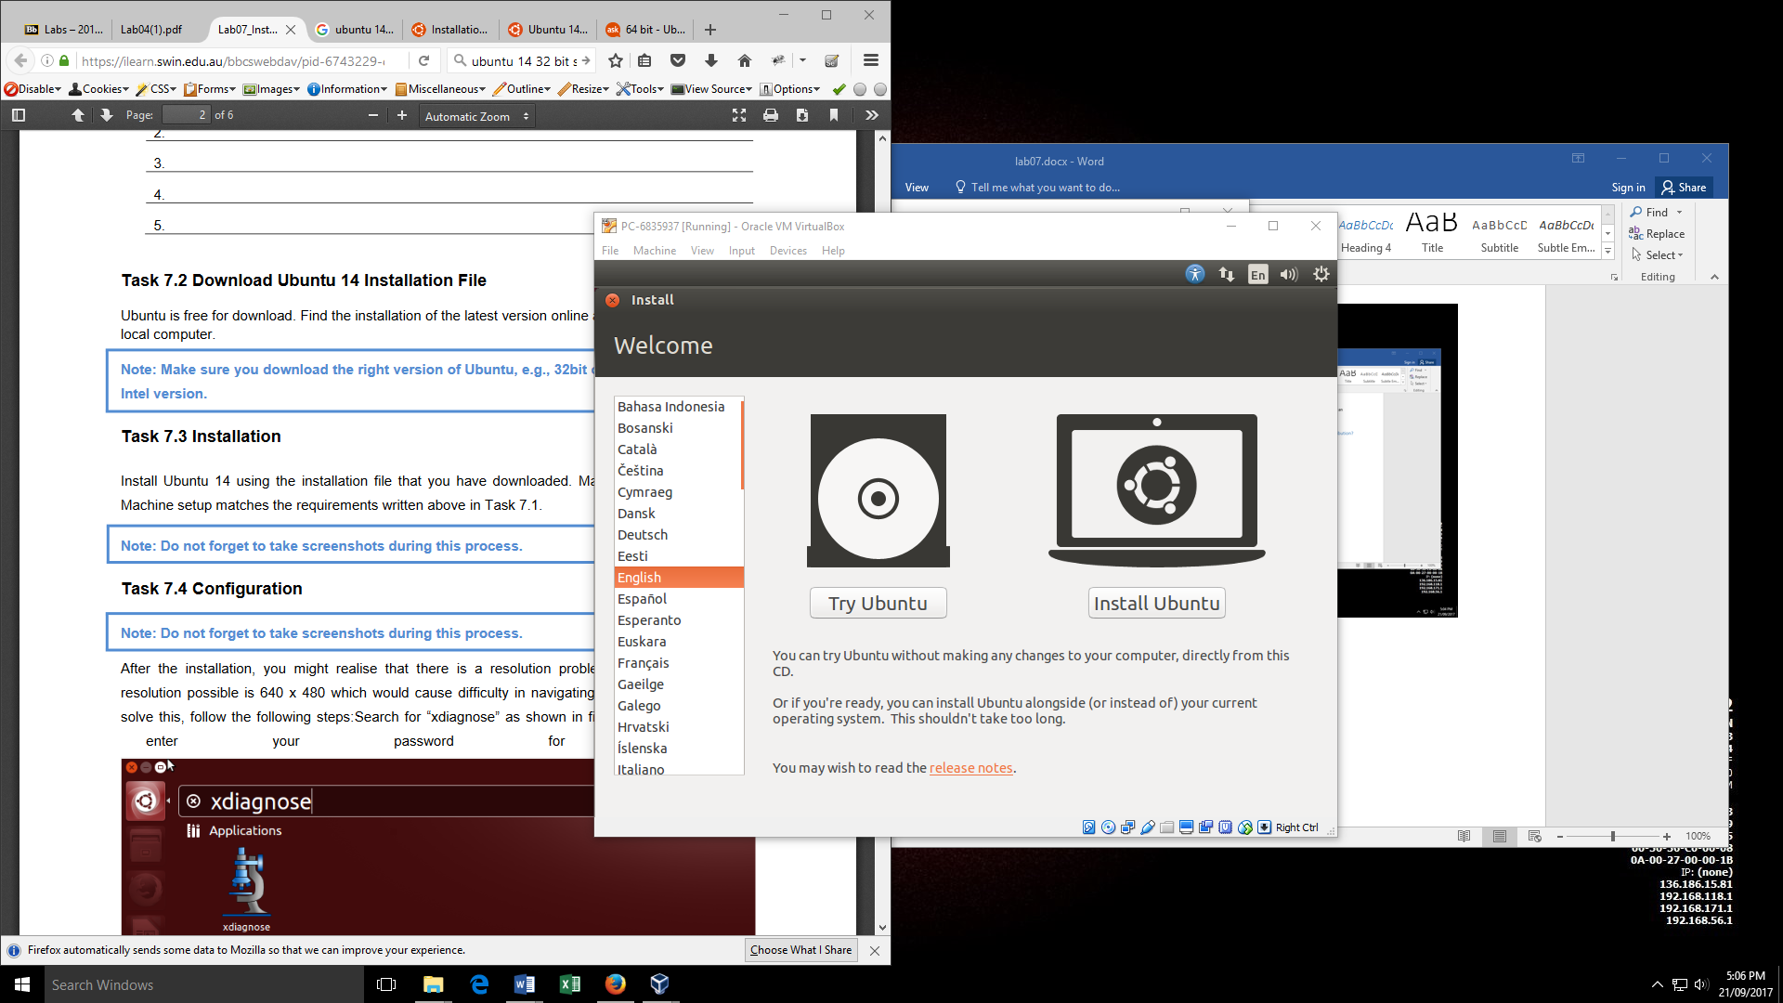

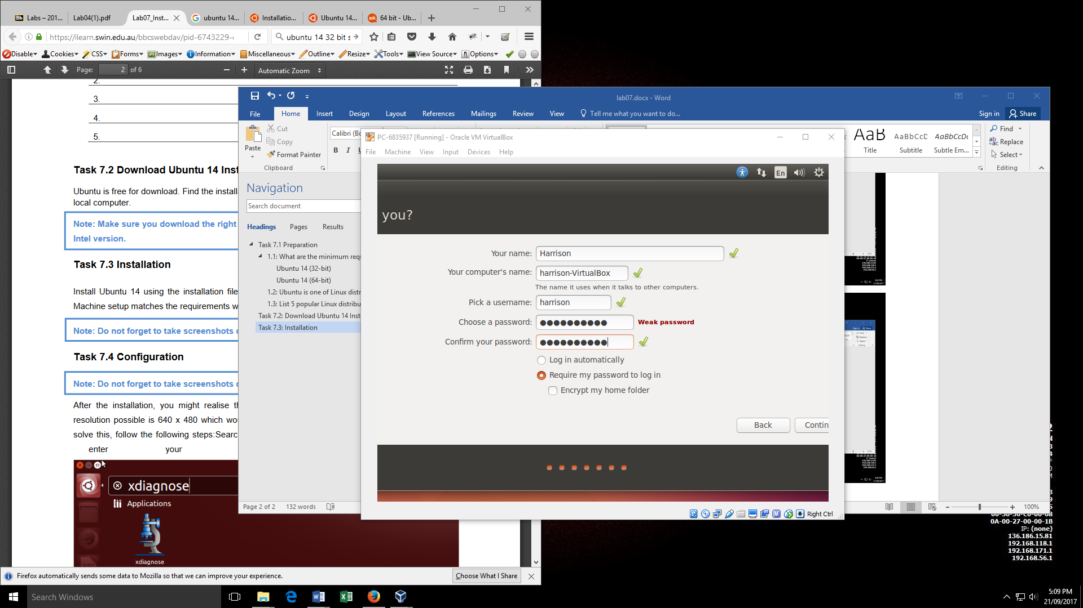

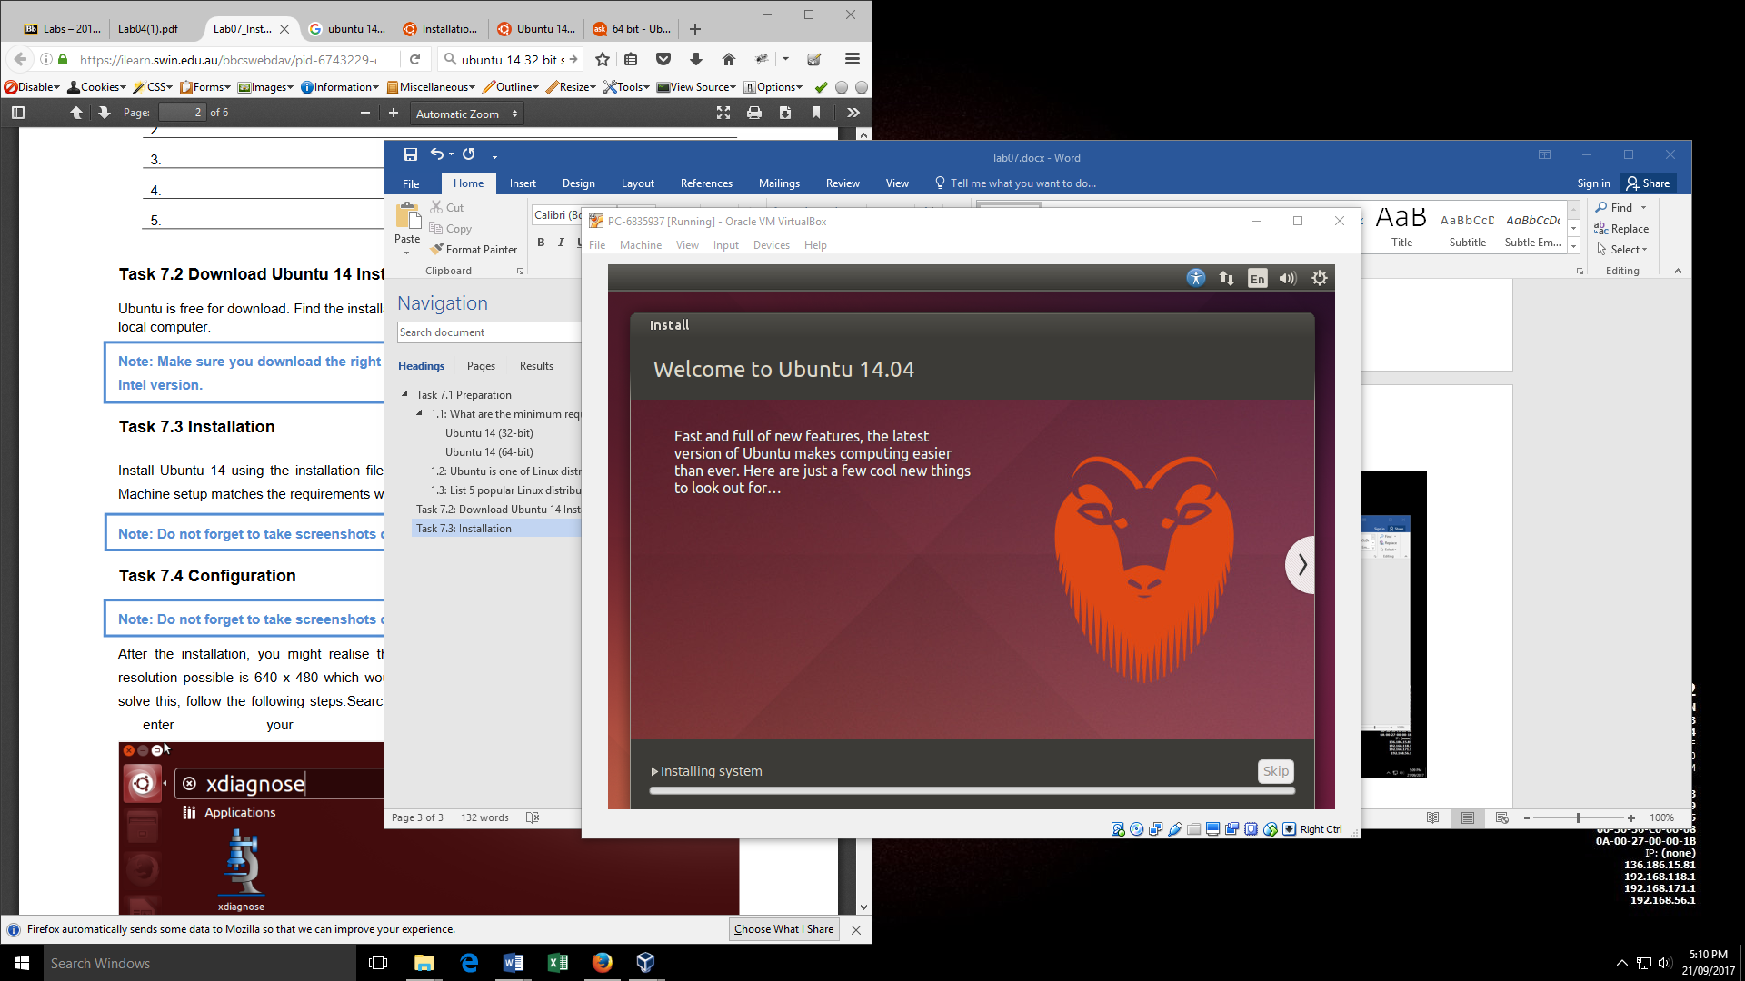

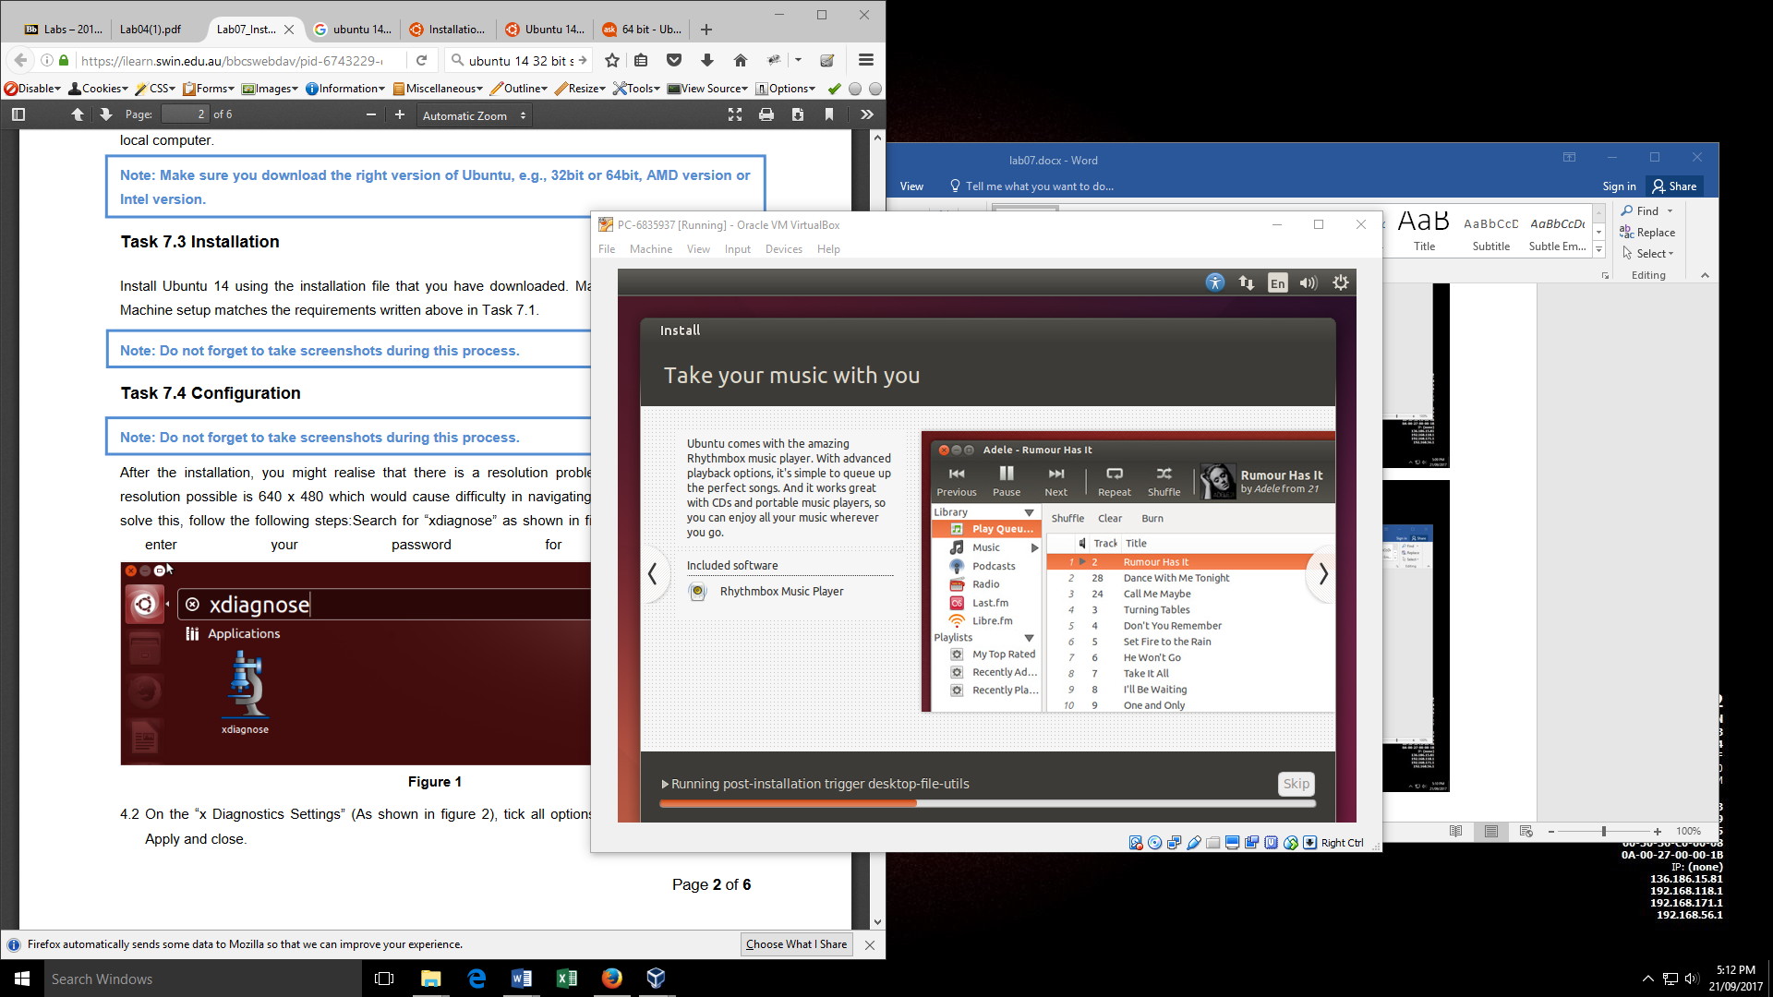

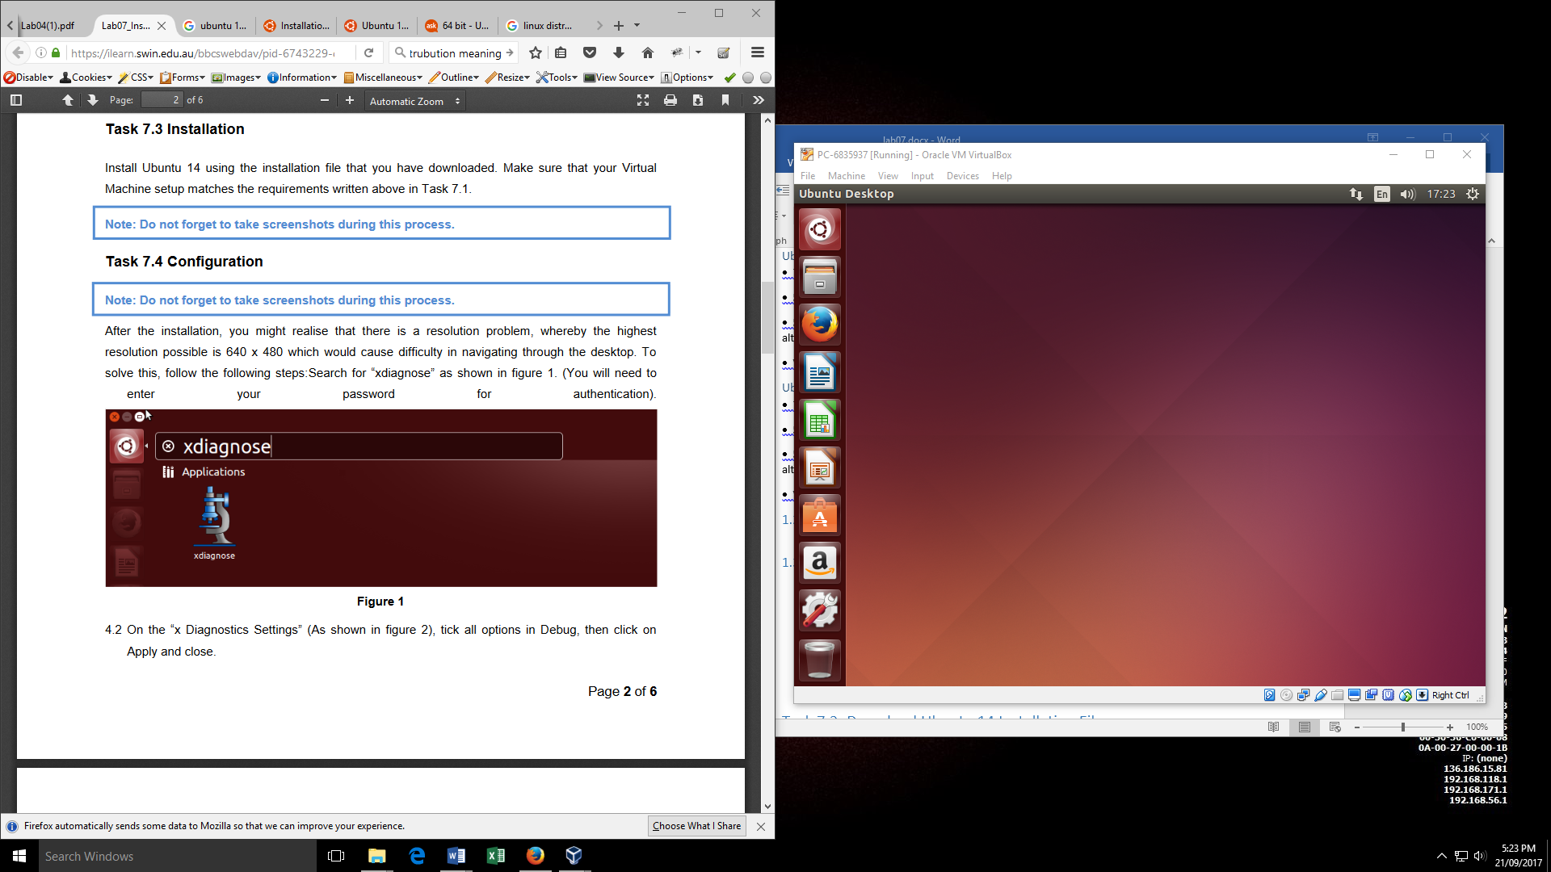

# 7.4: Configuration

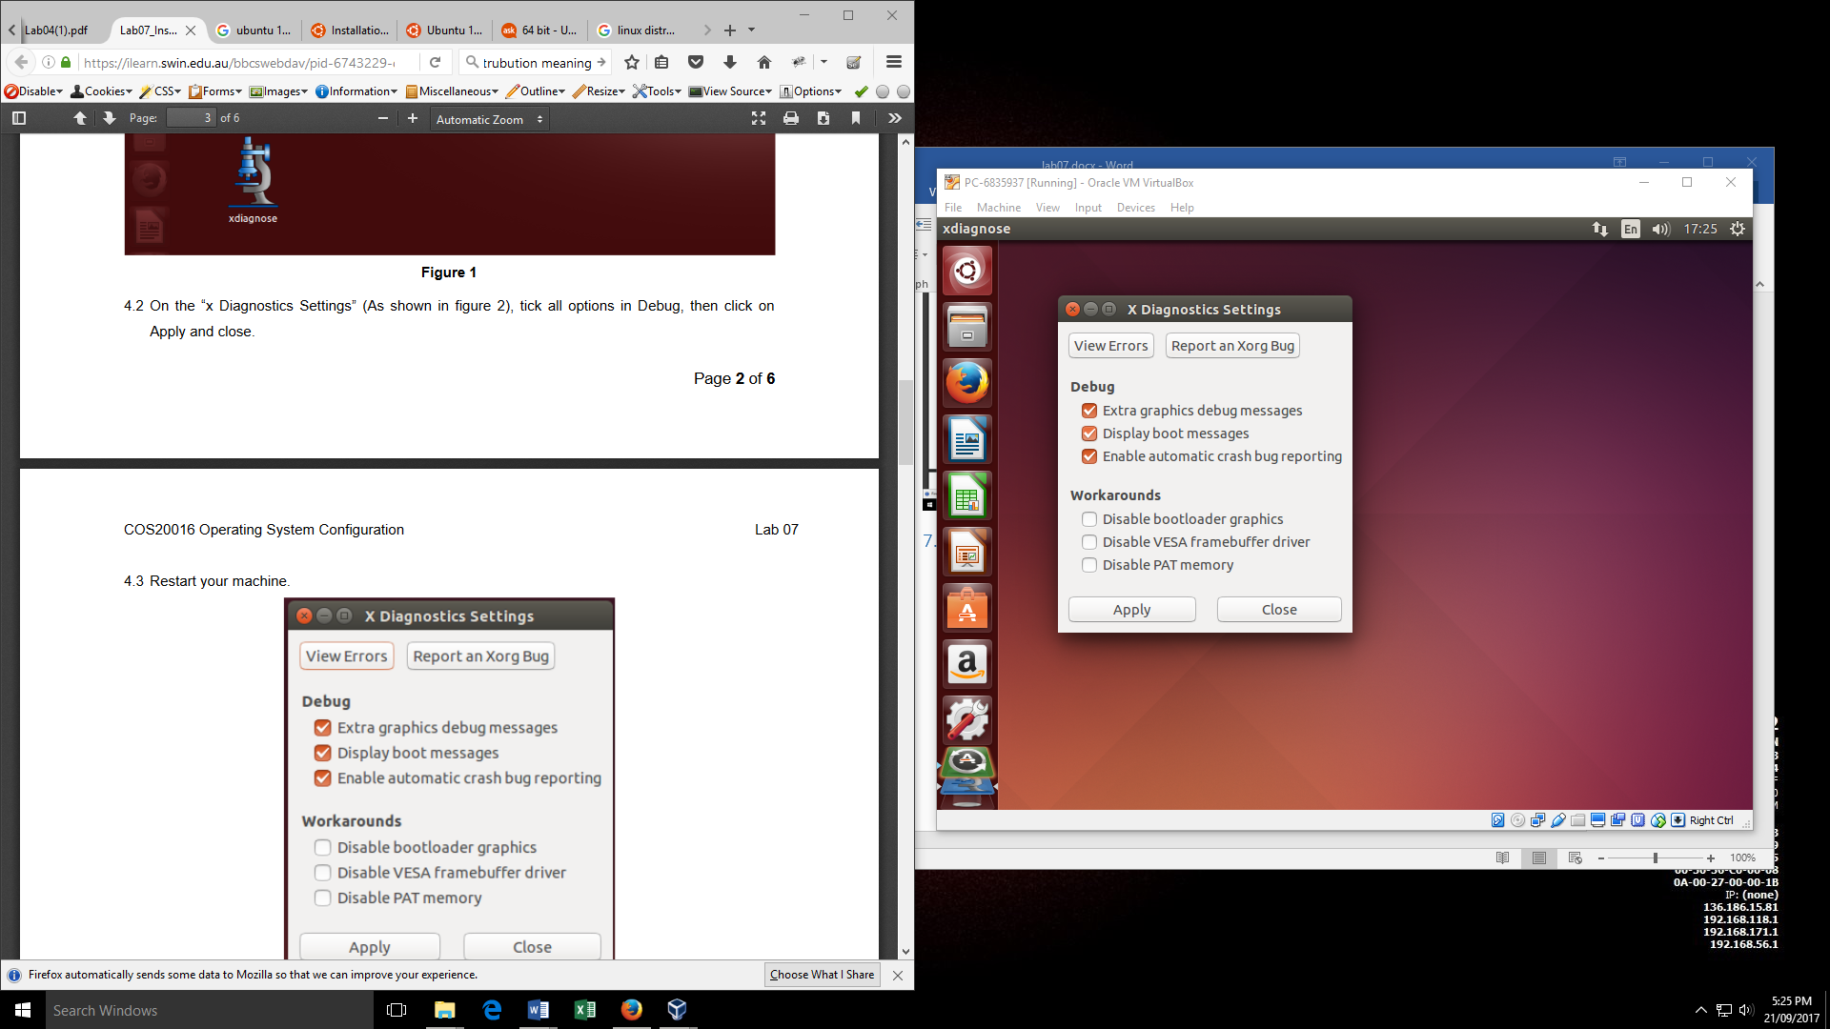

# 7.5: Proxy setup

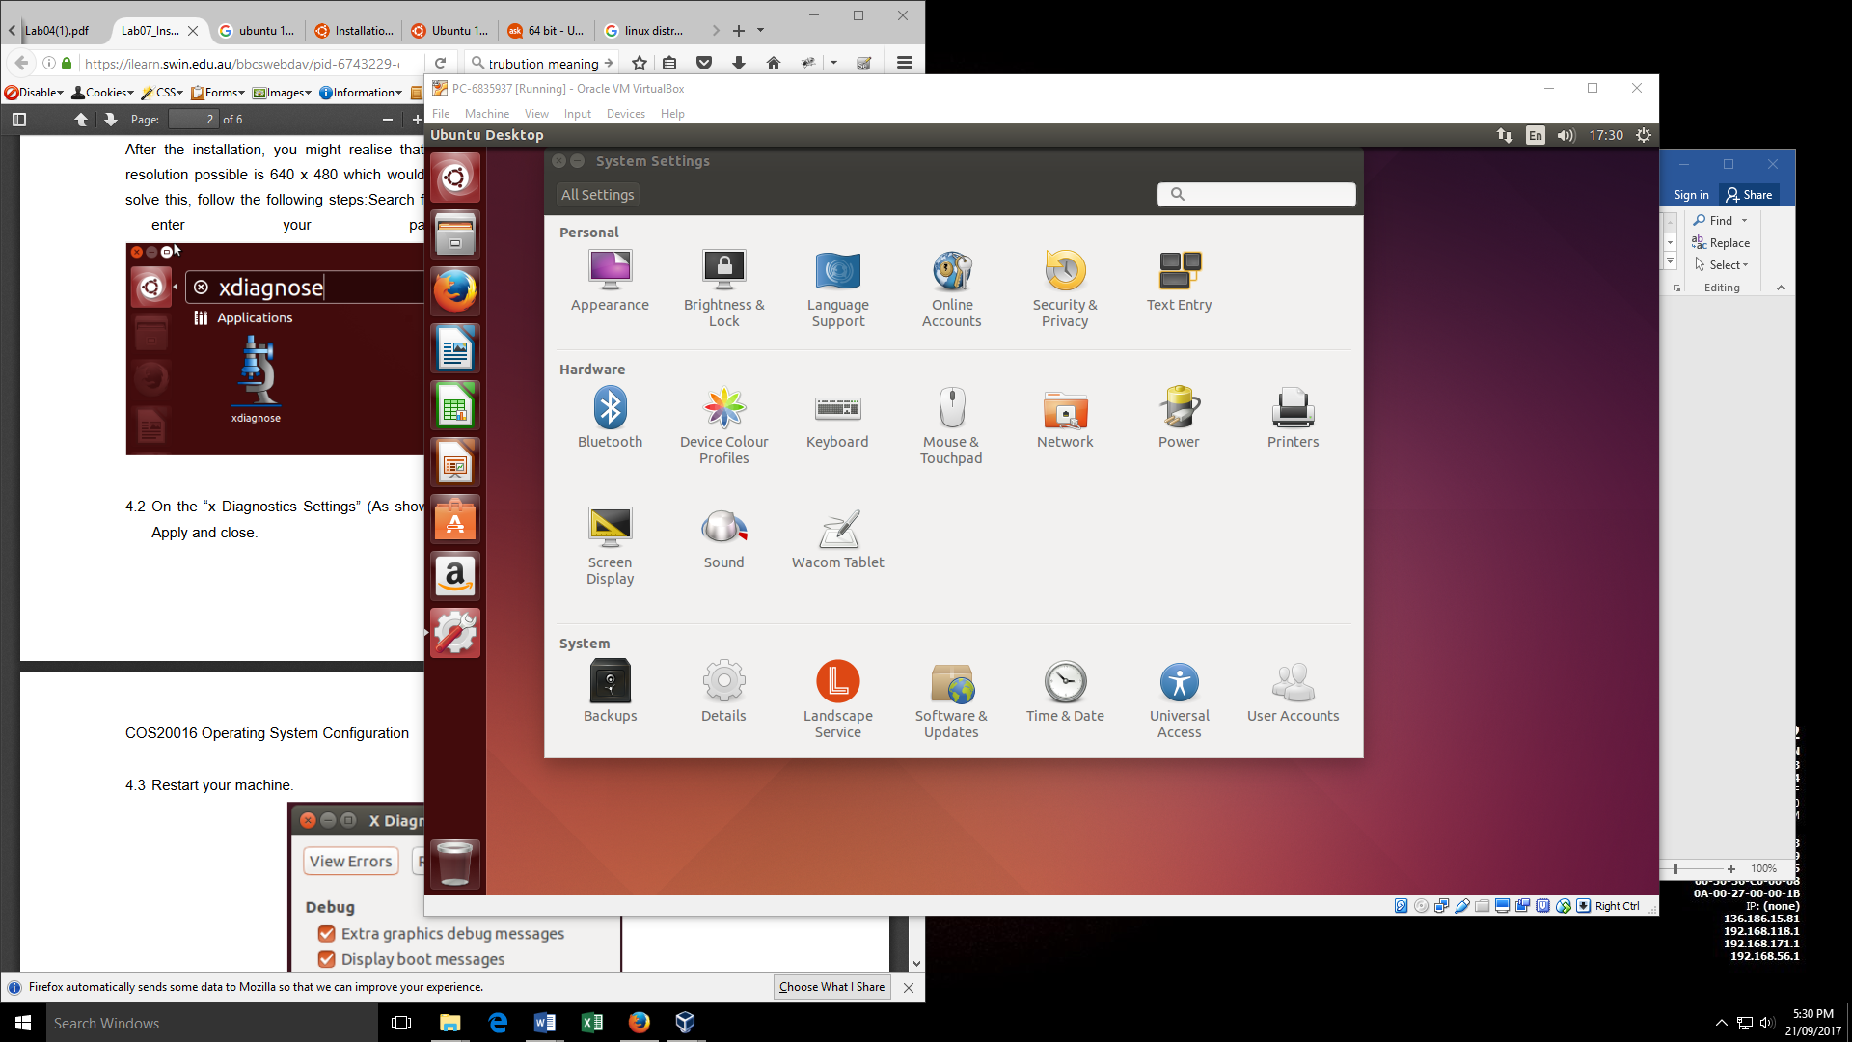

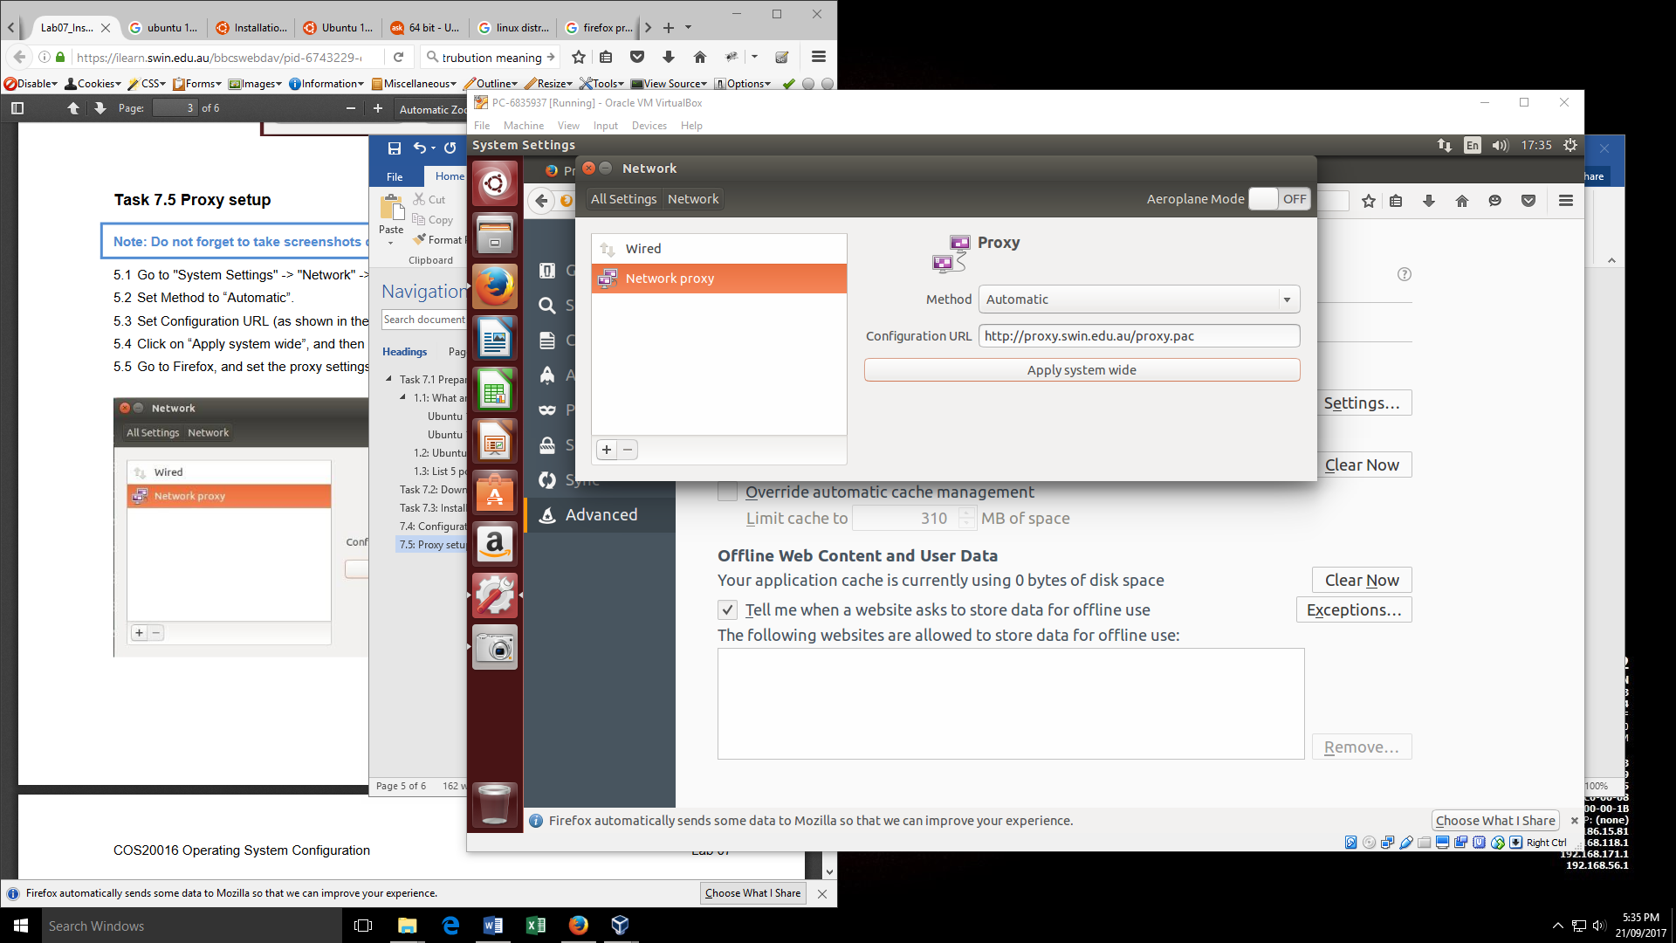

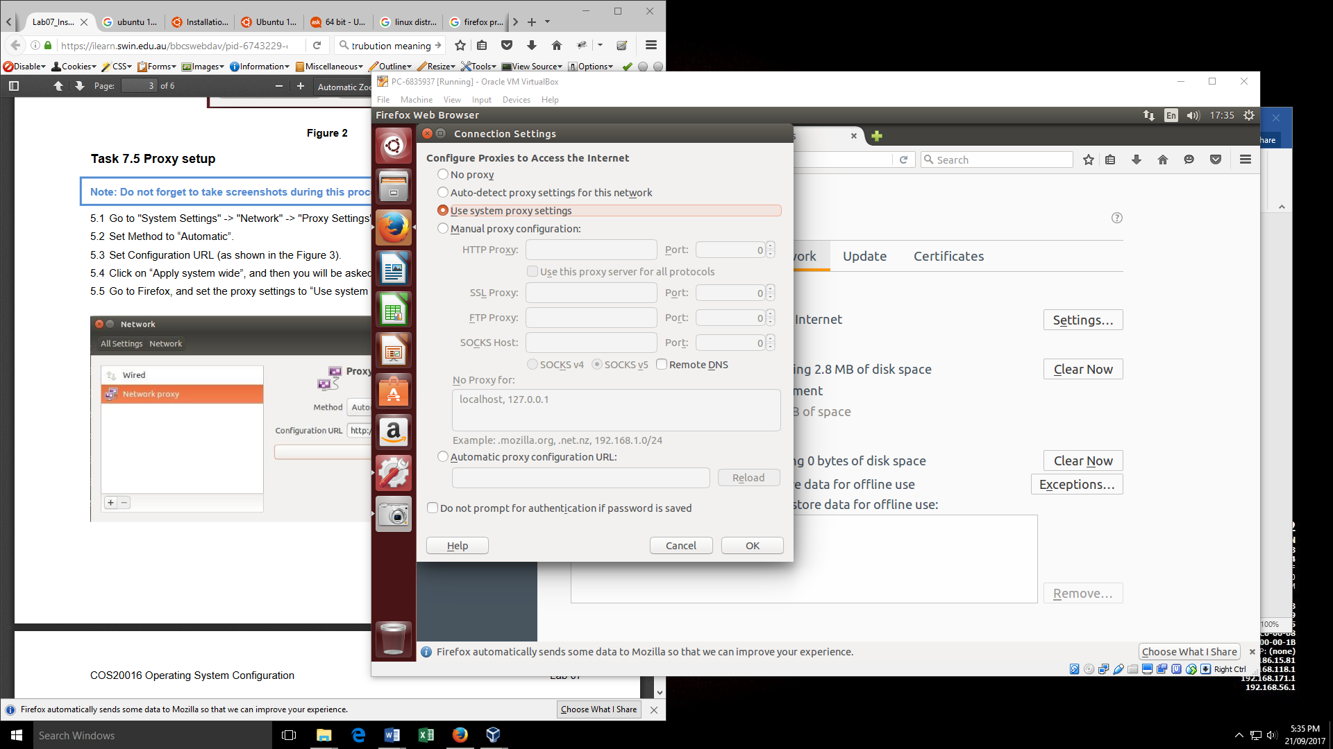

# Task 7.6: User Account with GUI

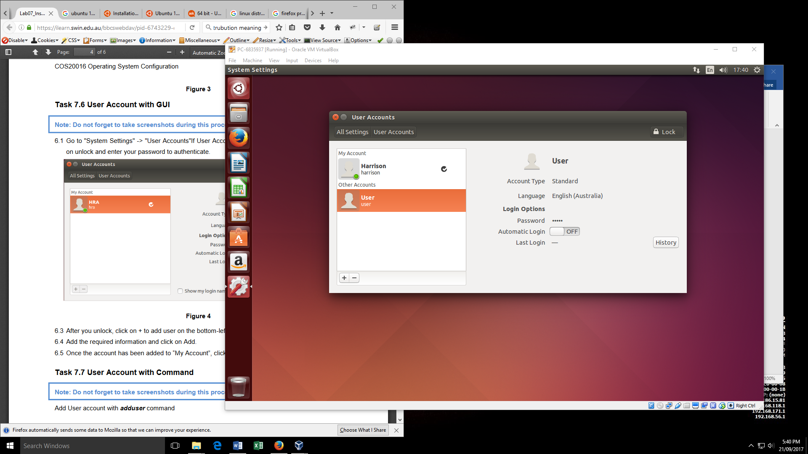

# Task 7.7: User Account with Command

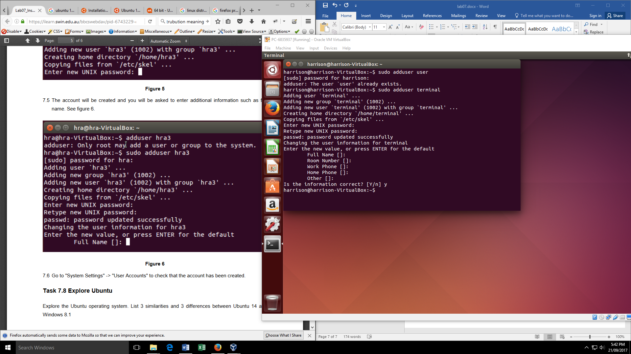

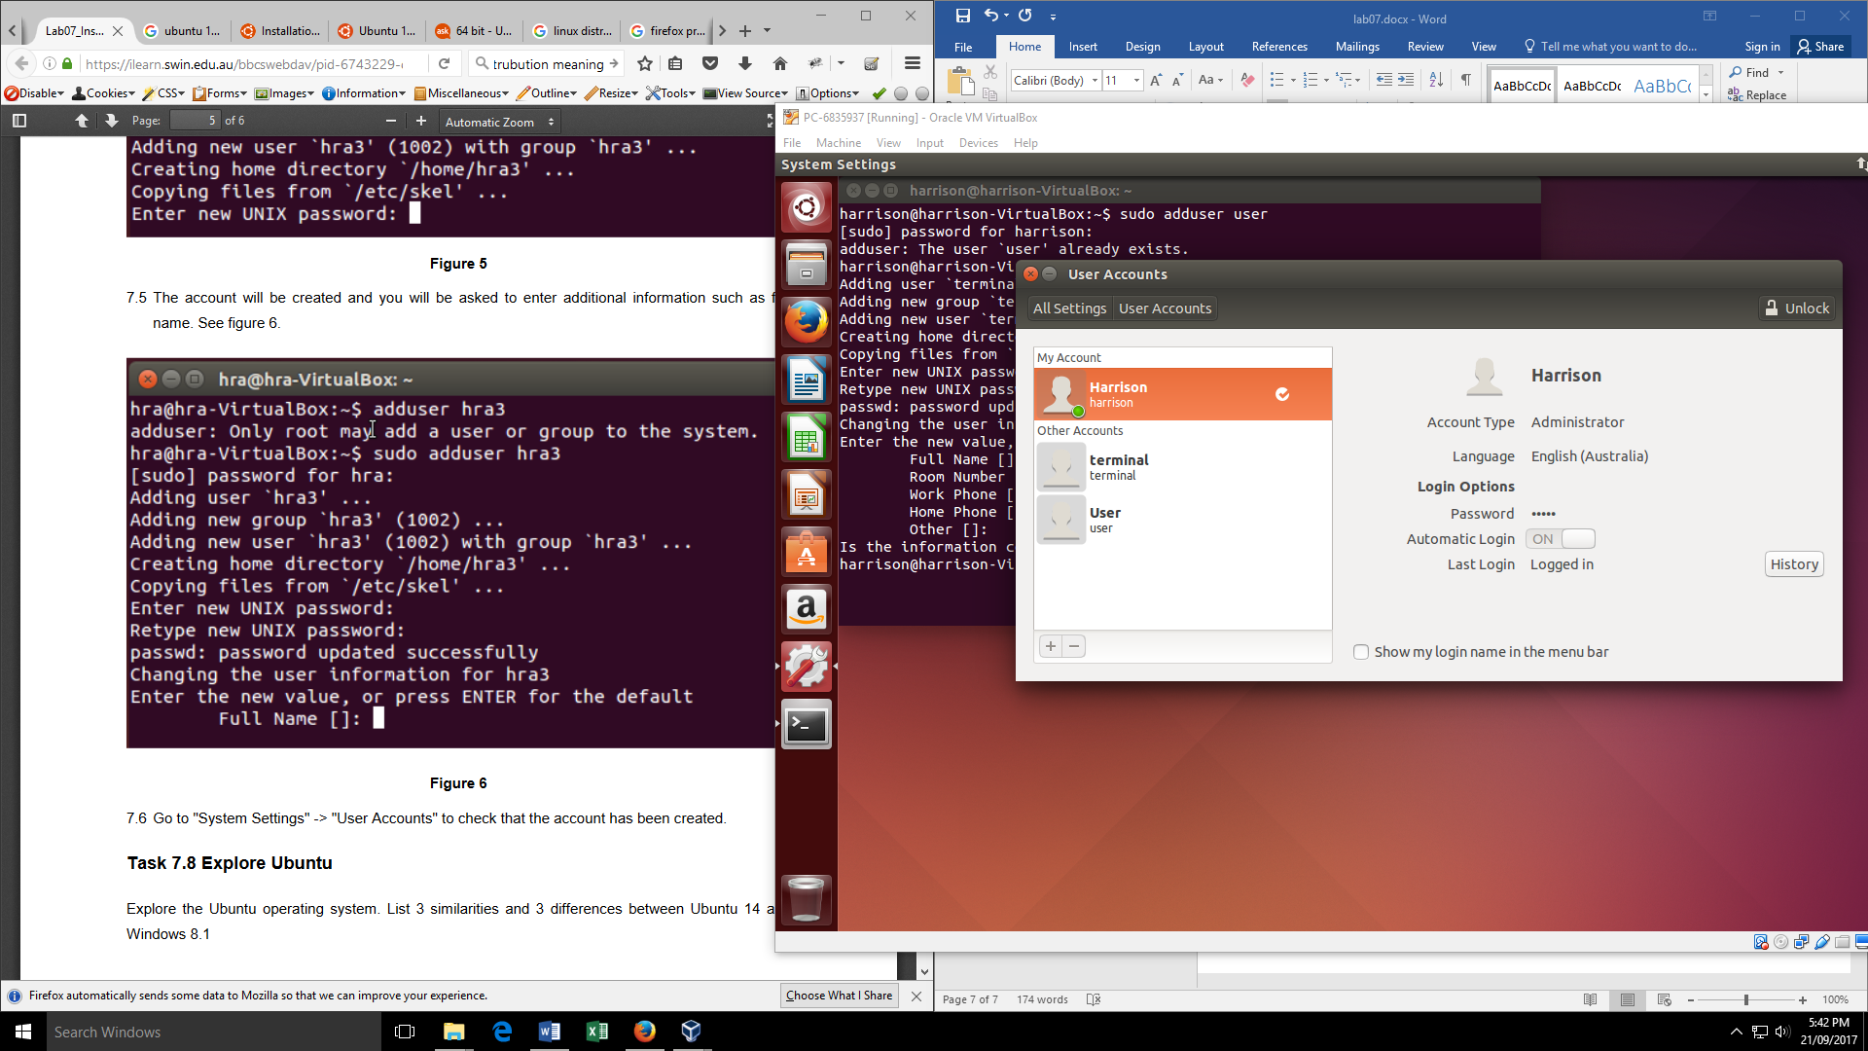

# 7.8: Explore Ubuntu